**DATABASE PROJECT**

**UNIVERSITIES**

BY NAFORNITA DANIELA ANDREA

CSIE YEAR 2

The target of the project is to design a database in a database management system(named SQL Oracle Developer) specially for usage of managing data about different universities in Bucharest. This project contains different tables who are managed specially to show what are the relations between different institutions, employees, and students.With this database, we will find out which universities are sponsorised by which sponsors(like Vodafone, Orange, Accenture), and more details about different students, and their teachers.

To be more explicit, those are the main topics that we are going to talk about:

1. The database schema for the project and the relation between the tables
2. Tables and constraints, exemplifying DDL statements on the tables: CREATE, ALTER, DROP.
3. Using DML statements: INSERT, UPDATE, DELETE, and MERGE, and a table who contains a row with the name of the student.
4. Diverse and relevant SELECT statements for the project theme that will contain (combined) all of the following elements:
5. >, =, <=, !=, IS NULL, LIKE, IN, BETWEEN, ANY, ALL;
6. Joins (inner, outer);
7. Using aggregate functions, GROUP BY, HAVING;
8. Using single row functions (mandatory: TO_CHAR, TO_DATE, EXTRACT, SUBSTR, SYSDATE, DECODE, CASE, NVL);
9. Using the CASE statement;
10. Using UNION, MINUS, INTERSECT;
11. Simple and correlated subqueries;

* CREATE/INSERT/UPDATE/DELETE + SELECT;
* Constructing and manipulating other objects of the database: views, indexes, synonyms and sequences;
* Hierarchical queries (CONNECT BY, PRIOR, LEVEL, SYS_CONNECT_BY_PATH);

In order to be all clear, I have created 5 main tables who are about: sponsors, teachers, universities,gradebook, and students. In my opinion, those are the main options who we can relate to when we talk about managing a database for universities in general. Because most of them are in relations „many-to-many”, I have created some intermediary tabels who are in relation with minimum 2 main tables, and I named them as a combination of two in order to be easy to recognize them.

**1.**So, this is our schema for the database we are talking about:

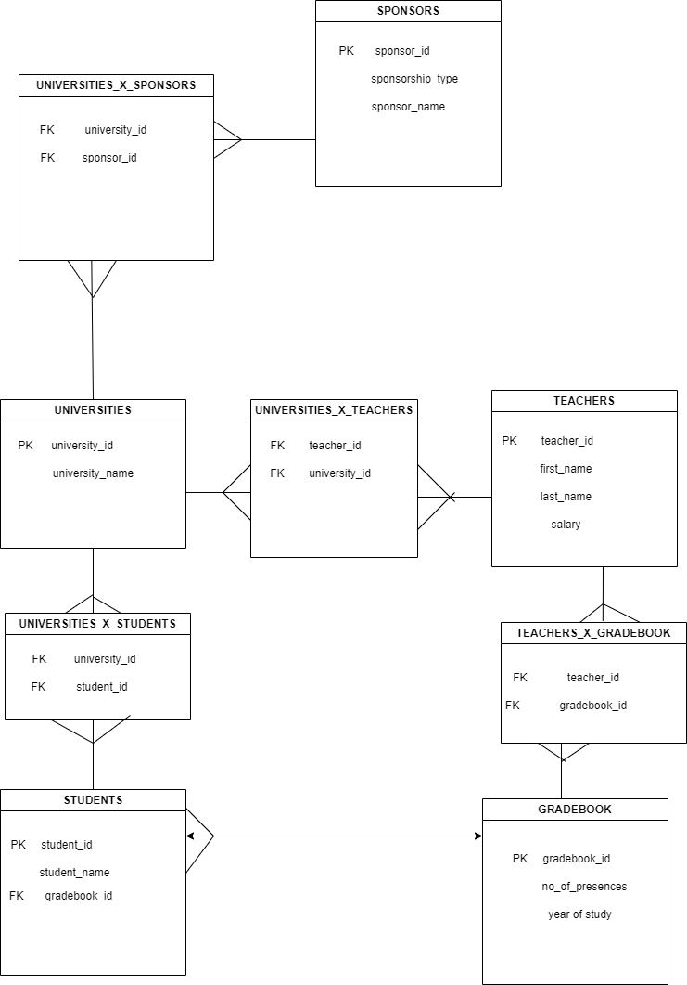

**From the table created below, we can conclude that: because most of the tables were in relation „many to many”, and it is forbidden to make a table like that and to make foreign keys and primary keys, I have created some „intermediary” tables who can give to the tables the relation „one to many” who is allowed to be made.**

**2.** Tables and constraints, exemplifying DDL statements on the tables: CREATE, ALTER, DROP.

***Firstly, we will create the tables with all primary keys*** and then we create foreign keys that depends on other primary keys from other tables.For example, table UNIVERSITIES_X_STUDENTS depends on tables: UNIVERSITIES, and STUDENTS.

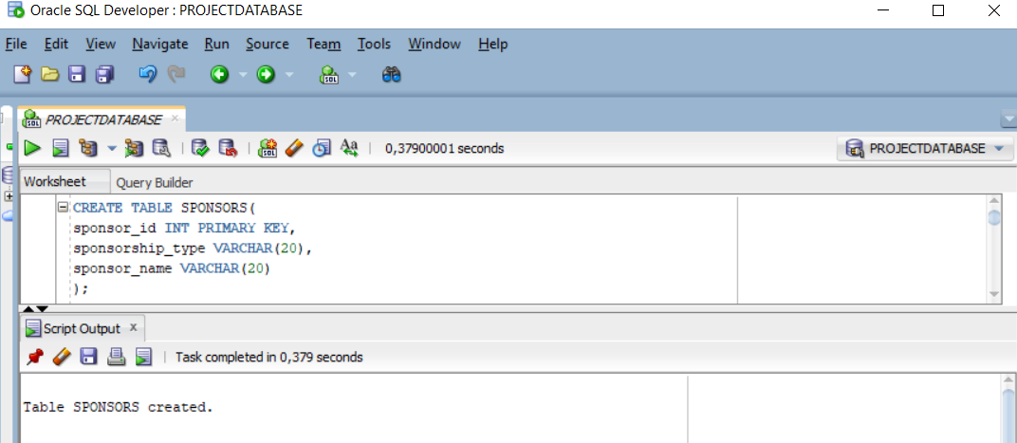

In this screenshot, I have created the table SPONSORS which has as rows a sponsor_id which is also a primary key and is an INT type, a sponsorship_type which is an VARCHAR type with maximum 20 characters, and a sponsor_name which is also a VARCHAR type with maximum 20 characters.

To continue with main tables, I have created TEACHERS table which contains the following rows: a teacher_id with the type of INT which is also a primary key, first_name who has a type of VARCHAR(20), last_name which has the same type as first_name, and salary which has a type of int.

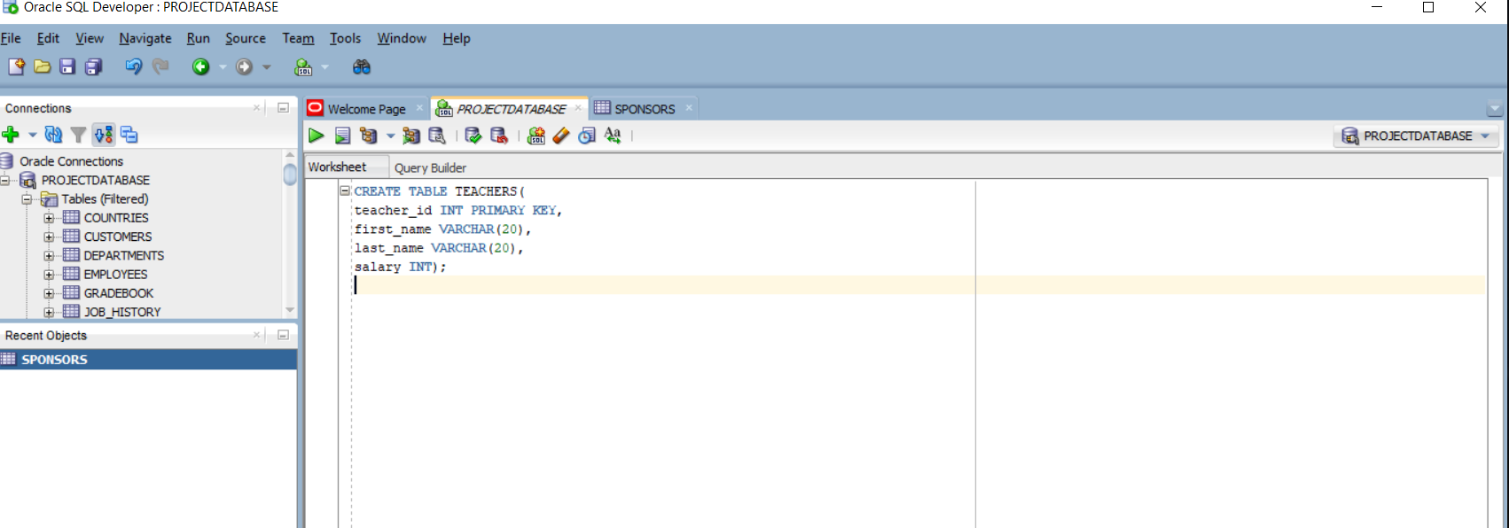

To continue, I have created table UNIVERSITIES which has the following rows: university_id which is also the primary key, and has a type of INT, university_name which has a type of VARCHAR(20).

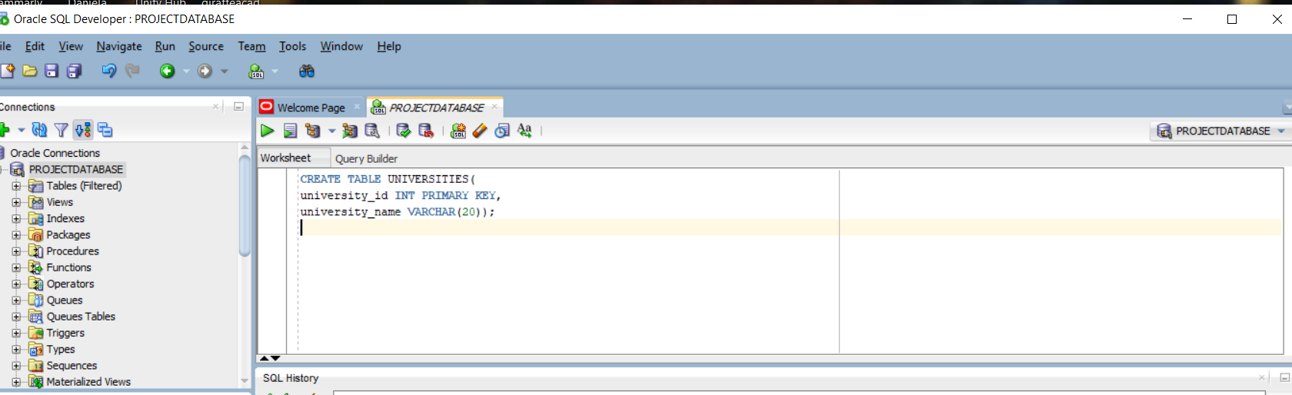

The following table is about GRADEBOOK, which nowadays it must be implemented online in order to be easier for the students and teachers to see and verify the situationships. So, those are the rows that I inserted: gradebook_id which has a type of INT and it’s also a primary key, number of presence and year of study which both are also a type of INT

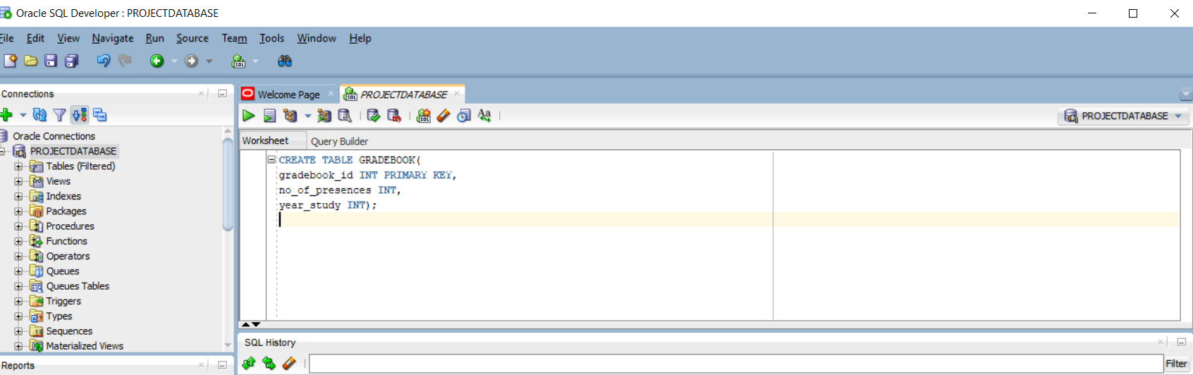

And, finally, I have created the table STUDENTS, which has the following rows: student_id which has a type of INT and is also a primary key, first_name and last_name which has a type of VARCHAR(20), gradebook_id of INT, which is a foreign key which is linked to the primary key in the gradebook table.This foreign key was set on delete to be set null, so if we want to delete it, it will be automatically set on NULL.

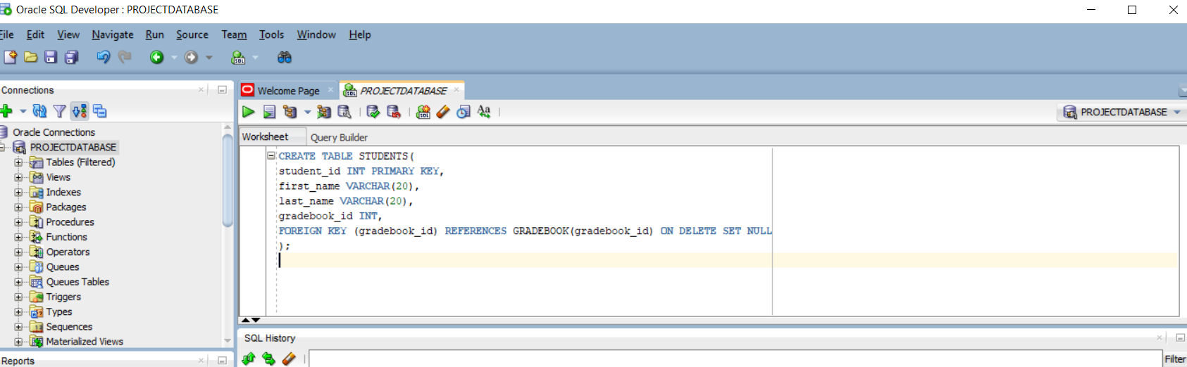

After creating those main tables, as I said in the first part of the project in the description, we should populate now those intermediary tables who gives us the opportunity to link tables who initially were in many to many relationship. We will begin with table UNIVERSITIES_X_STUDENTS which has the following rows: university_id and student_id. Those two have a type of INT and also are foreign keys linked to those two primary keys: university_id and student_id from tables UNIVERSITIES AND STUDENTS. Those two foreign keys were set on delete to be set null, so if we want to delete them, those will be automatically set on NULL.

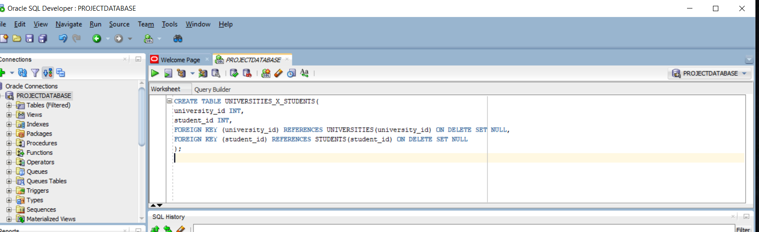

The following ones are created according to the same algorithm as the previous ones:

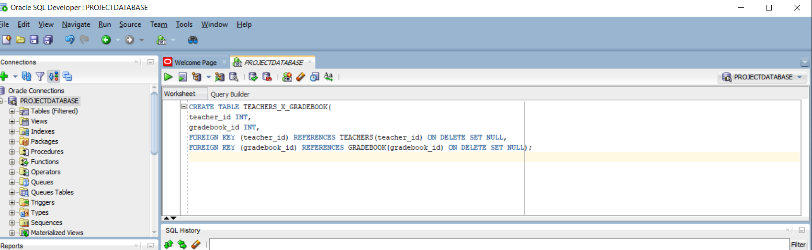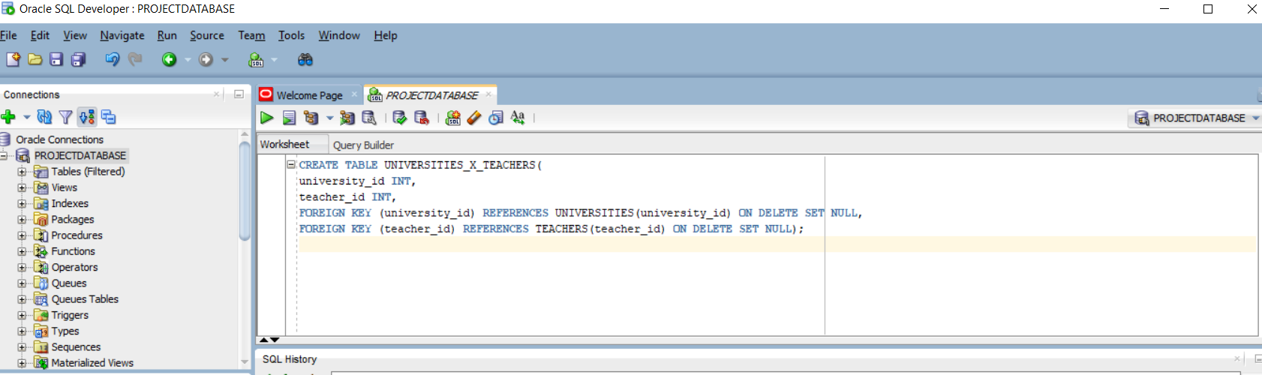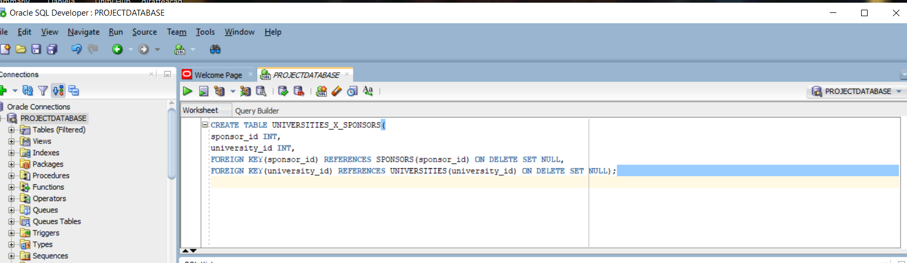

AFTER CREATING THOSE TABLES, I CREATE A NEW EXTRA TABLE AS IT WAS MANDATORY WITH MY NAME IN IT:

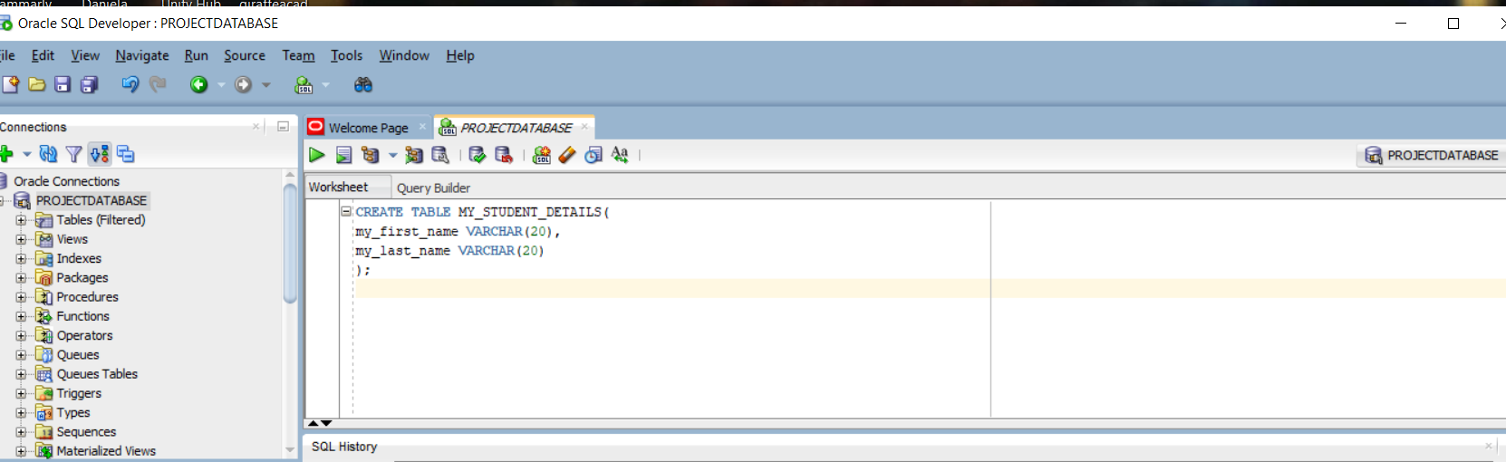

***Secondly, we will create some ALTER commands***, as we should:

I chose to do some ALTER commands with ADD:

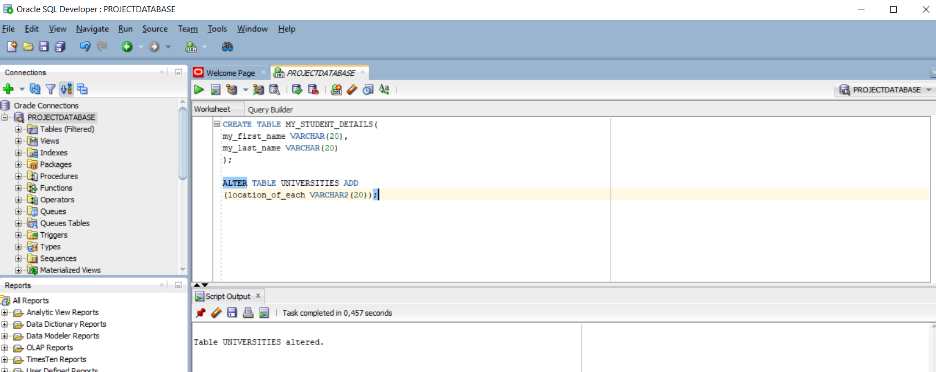

In the screenshot who is above, I have modified the table UNIVERSITIES by adding an array of characters who describes the location of each university.

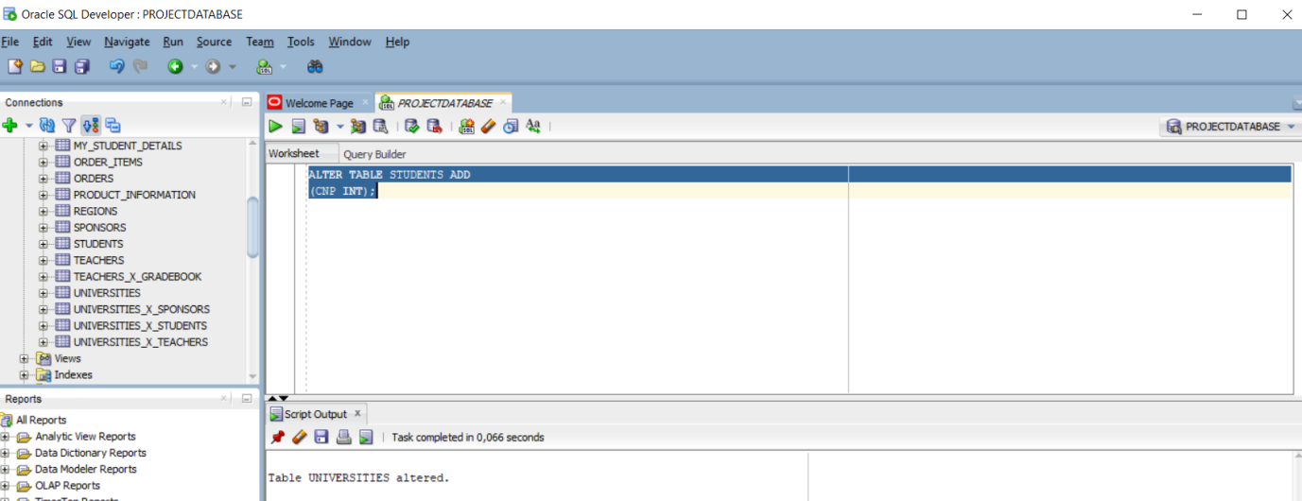

In the second screenshot, I have modified table STUDENTS by adding a new row named CNP which has a type of INT

In the third screenshot I have modified the table STUDENTS by adding a new row named BIRTH DATE which has a type of DATE.

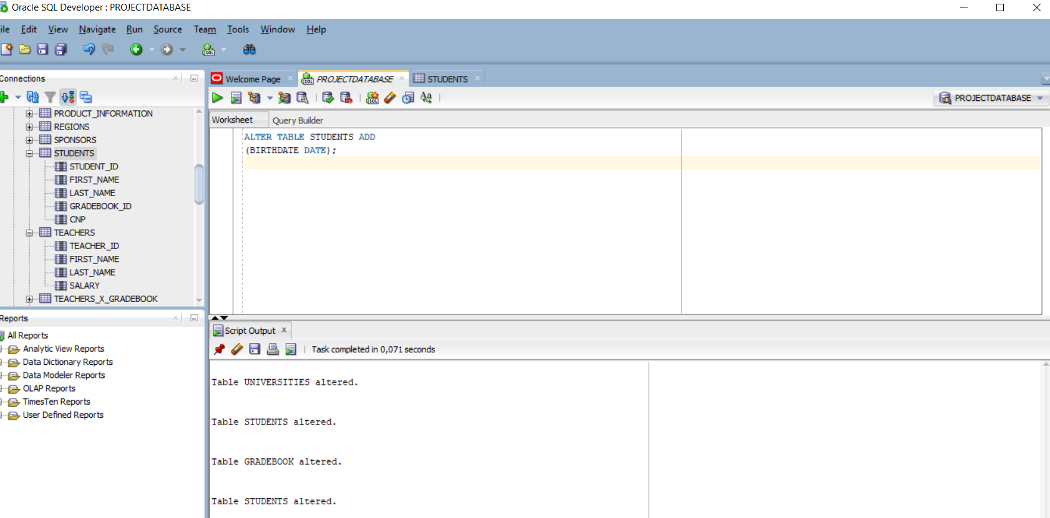

Same as STUDENTS, I have added a new row named BIRTH DATE but this time for table TEACHERS.

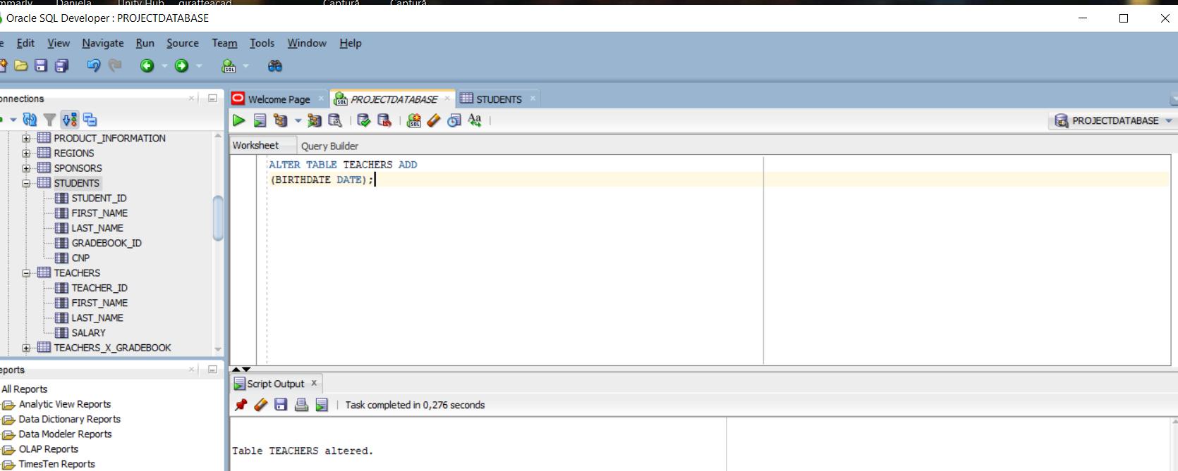

In the table UNIVERSITIES_X_SPONSORS, I have modified by „ALTER” statement by adding as previous, the row named DATE OF BEGIN which has a type of INT.

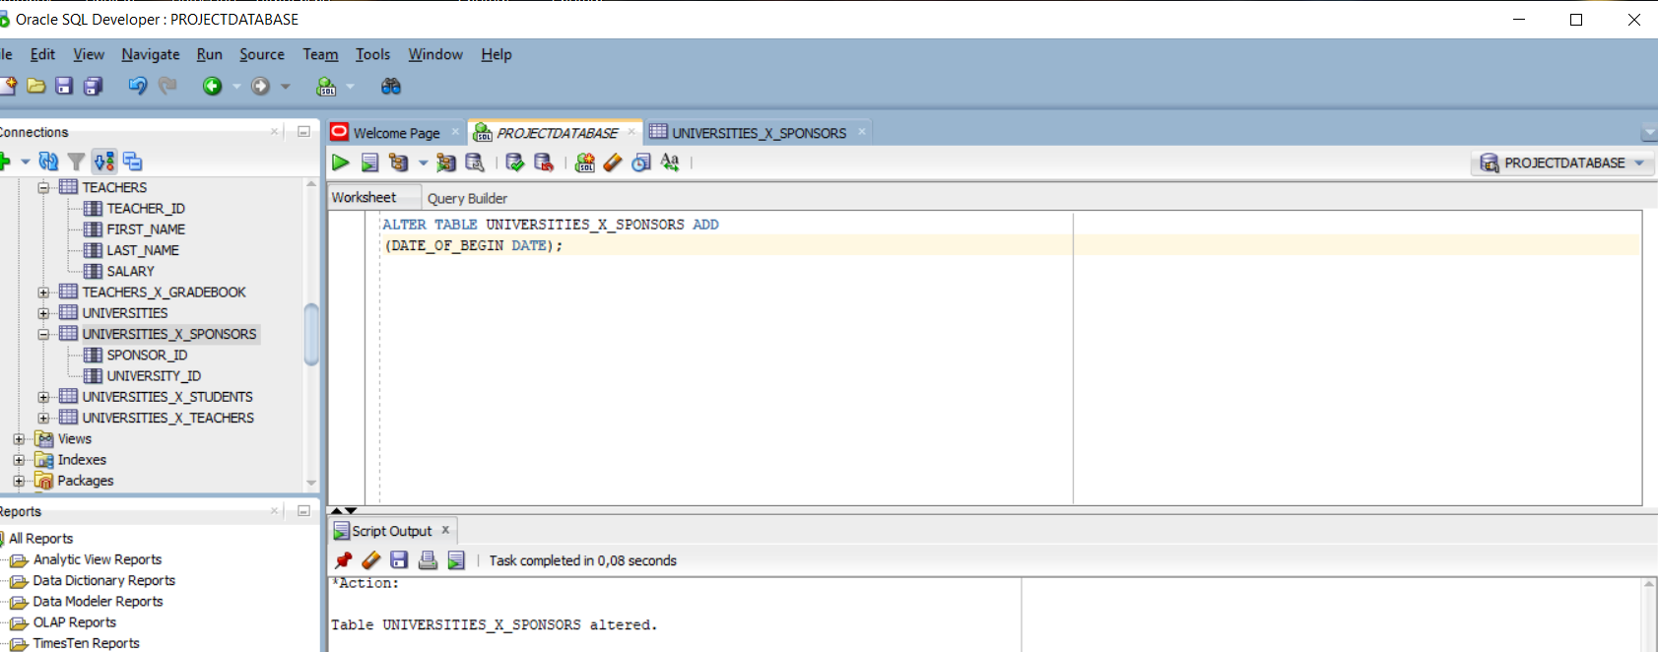

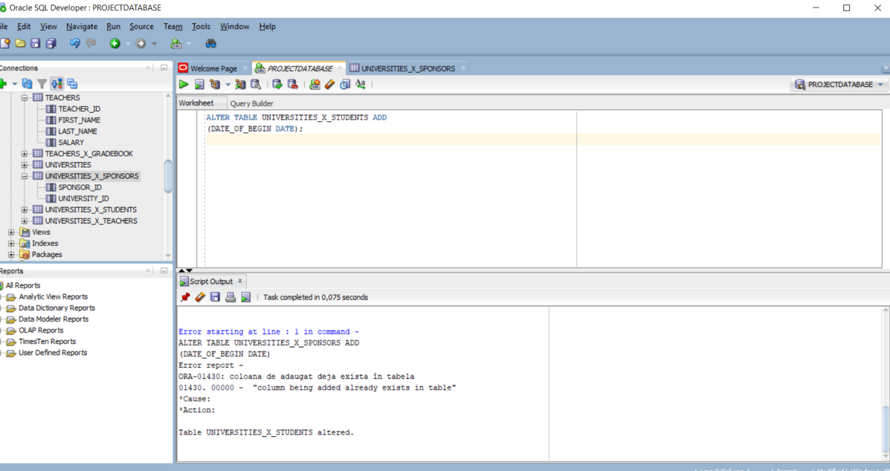In the last „ALTER” statement, I have modified in the table UNIVERSITIES_X_STUDENTS same as previous ones.

The **third requirement** is to add some DROP statements. And those are the following ones:

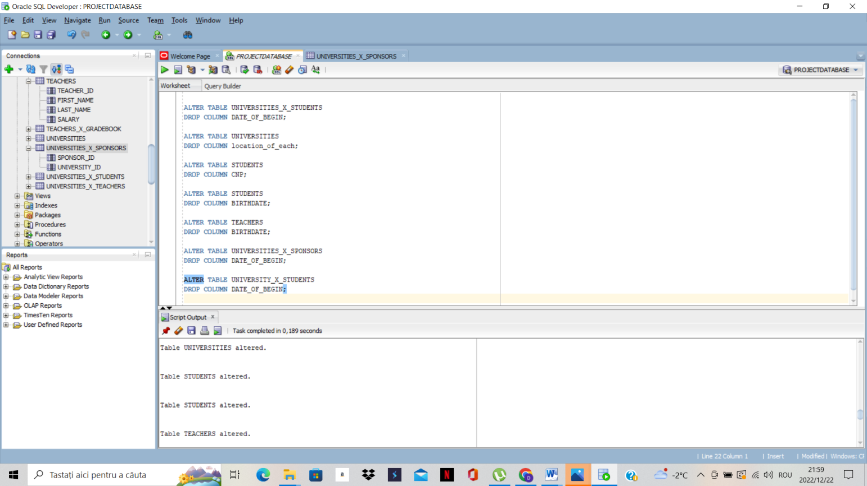

3.***Using DML statements: INSERT, UPDATE, DELETE, and MERGE***, and a table who contains a row with the name of the student.

Firstly, I will insert some data into the database with informations about students, teachers, universities, gradebook, and sponsors.

1)informations about SPONSORS

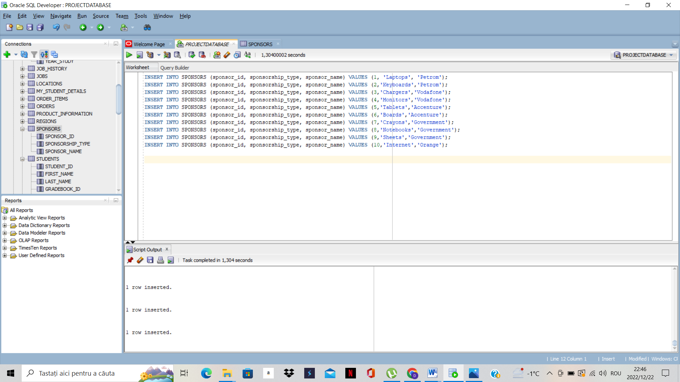

INSERT INTO SPONSORS (sponsor_id, sponsorship_type, sponsor_name) VALUES (1, 'Laptops', 'Petrom');

INSERT INTO SPONSORS (sponsor_id, sponsorship_type, sponsor_name) VALUES (2,'Keyboards','Petrom');

INSERT INTO SPONSORS (sponsor_id, sponsorship_type, sponsor_name) VALUES (3,'Chargers','Vodafone');

INSERT INTO SPONSORS (sponsor_id, sponsorship_type, sponsor_name) VALUES (4,'Monitors','Vodafone');

INSERT INTO SPONSORS (sponsor_id, sponsorship_type, sponsor_name) VALUES (5,'Tablets','Accenture');

INSERT INTO SPONSORS (sponsor_id, sponsorship_type, sponsor_name) VALUES (6,'Boards','Accenture');

INSERT INTO SPONSORS (sponsor_id, sponsorship_type, sponsor_name) VALUES (7,'Crayons','Government');

INSERT INTO SPONSORS (sponsor_id, sponsorship_type, sponsor_name) VALUES (8,'Notebooks','Government');

INSERT INTO SPONSORS (sponsor_id, sponsorship_type, sponsor_name) VALUES (9,'Sheets','Government');

INSERT INTO SPONSORS (sponsor_id, sponsorship_type, sponsor_name) VALUES (10,'Internet','Orange');

2)Informations about UNIVERSITIES

In this table I omitted to copy paste the informations from the sql developer, but instead I still have the screenshot about the informations:

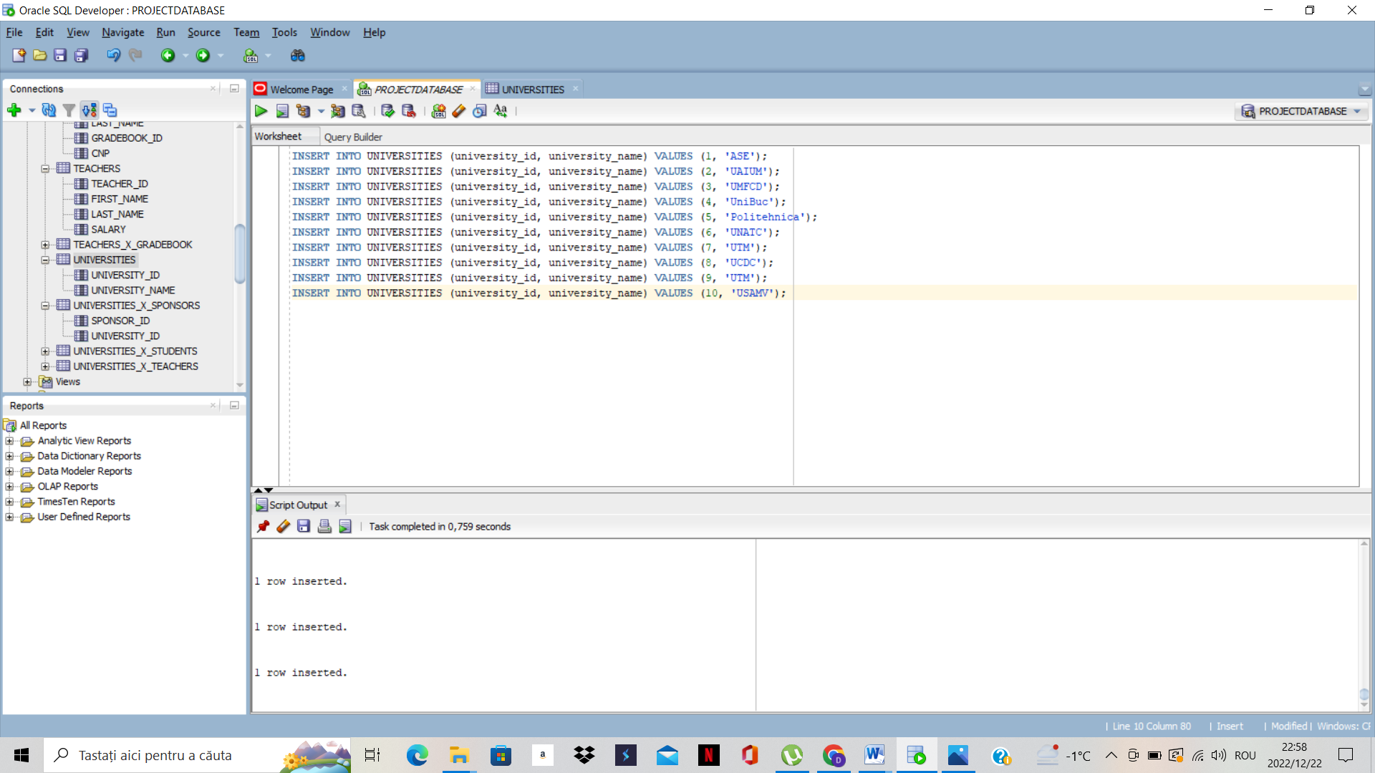

4) Informations about STUDENTS:

INSERT INTO STUDENTS (student_id, first_name,last_name, gradebook_id) VALUES (1,'Popescu','Andrei',1);

INSERT INTO STUDENTS (student_id, first_name,last_name, gradebook_id) VALUES (2,'Ionsecu','Camelia',2);

INSERT INTO STUDENTS (student_id, first_name,last_name, gradebook_id) VALUES (3,'Popescu','Andreea',3);

INSERT INTO STUDENTS (student_id, first_name,last_name, gradebook_id) VALUES (4,'Anghel','Damian',4);

INSERT INTO STUDENTS (student_id, first_name,last_name, gradebook_id) VALUES (5,'Popovici','Luiza',5);

INSERT INTO STUDENTS (student_id, first_name,last_name, gradebook_id) VALUES (6,'Mihalovici','Radu',6);

INSERT INTO STUDENTS (student_id, first_name,last_name, gradebook_id) VALUES (7,'Popescu','Andrei',7);

INSERT INTO STUDENTS (student_id, first_name,last_name, gradebook_id) VALUES (8,'Nafornita','Andrea',8);

INSERT INTO STUDENTS (student_id, first_name,last_name, gradebook_id) VALUES (9,'Popovici','Andrei',9);

INSERT INTO STUDENTS (student_id, first_name,last_name, gradebook_id) VALUES (10,'Davidescu','Andra',10);

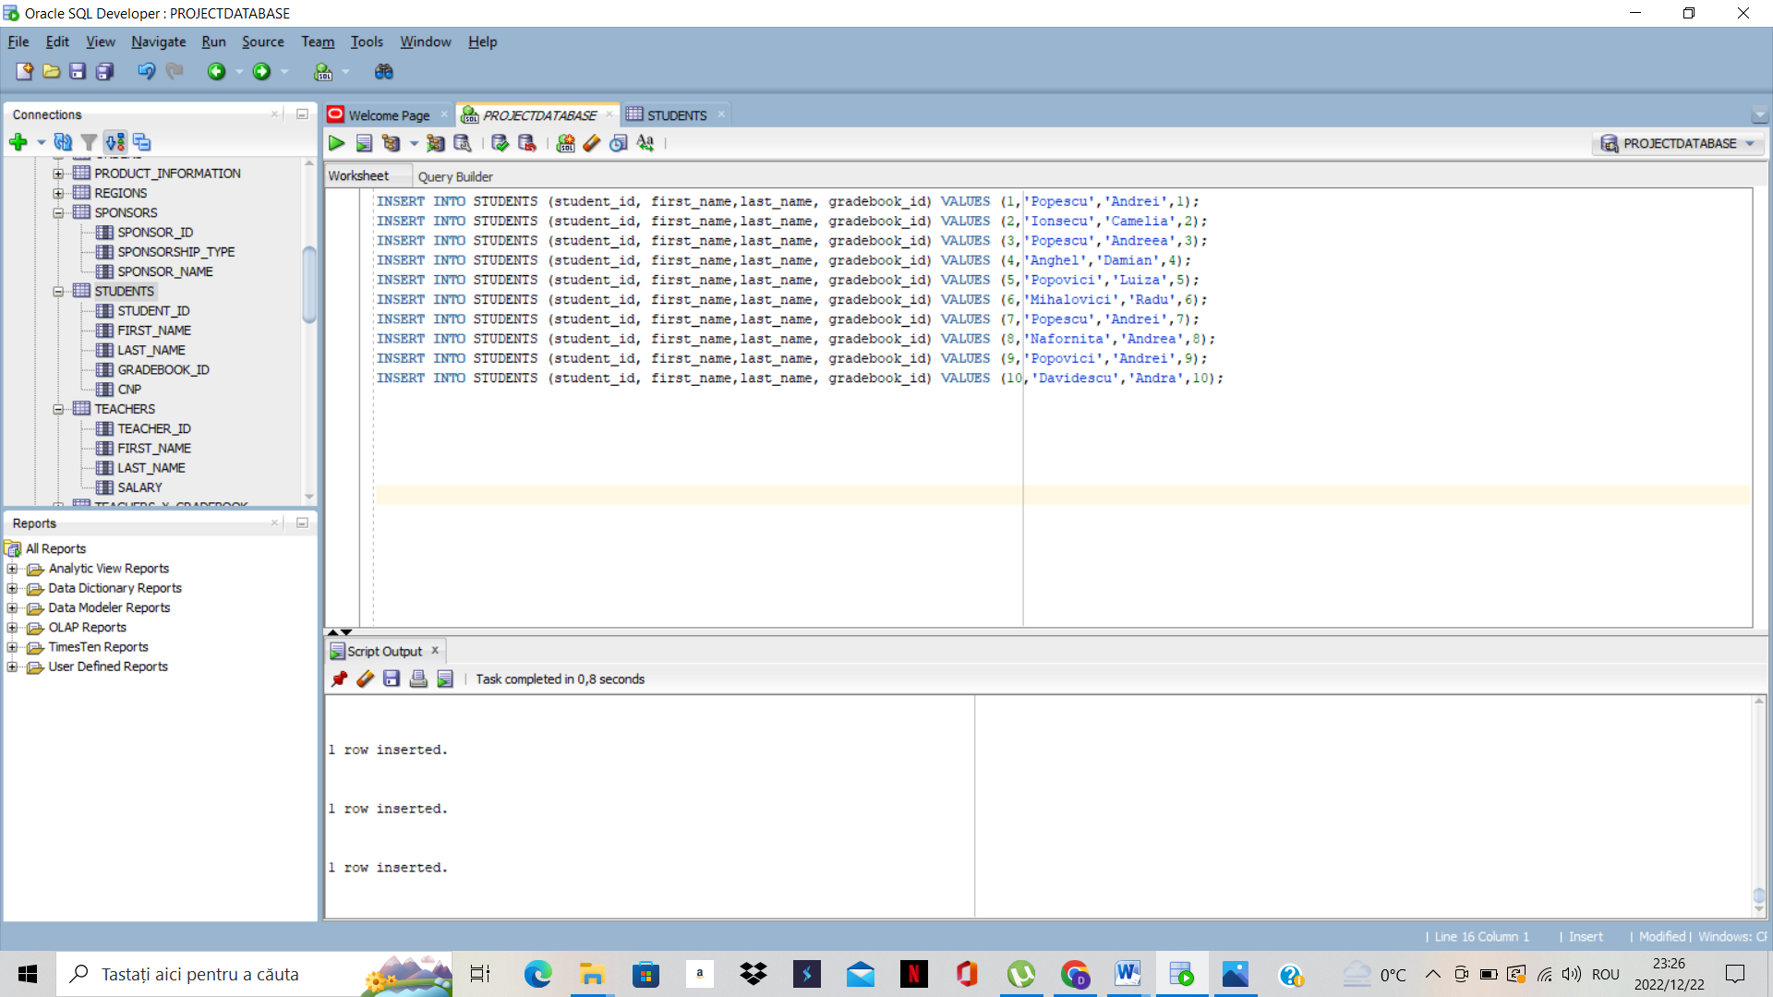

5)Informations about GRADEBOOK:

INSERT INTO GRADEBOOK (gradebook_id, no_of_presences, year_study) VALUES (1, 100, 1);

INSERT INTO GRADEBOOK (gradebook_id, no_of_presences, year_study) VALUES (3, 120, 2);

INSERT INTO GRADEBOOK (gradebook_id, no_of_presences, year_study) VALUES (4, 100, 2);

INSERT INTO GRADEBOOK (gradebook_id, no_of_presences, year_study) VALUES (5, 150, 3);

INSERT INTO GRADEBOOK (gradebook_id, no_of_presences, year_study) VALUES (6, 10, 4);

INSERT INTO GRADEBOOK (gradebook_id, no_of_presences, year_study) VALUES (7, 300, 2);

INSERT INTO GRADEBOOK (gradebook_id, no_of_presences, year_study) VALUES (8, 200, 1);

INSERT INTO GRADEBOOK (gradebook_id, no_of_presences, year_study) VALUES (9, 300, 2);

INSERT INTO GRADEBOOK (gradebook_id, no_of_presences, year_study) VALUES (10, 200, 3);

INSERT INTO GRADEBOOK (gradebook_id, no_of_presences, year_study) VALUES (11, 110, 1);

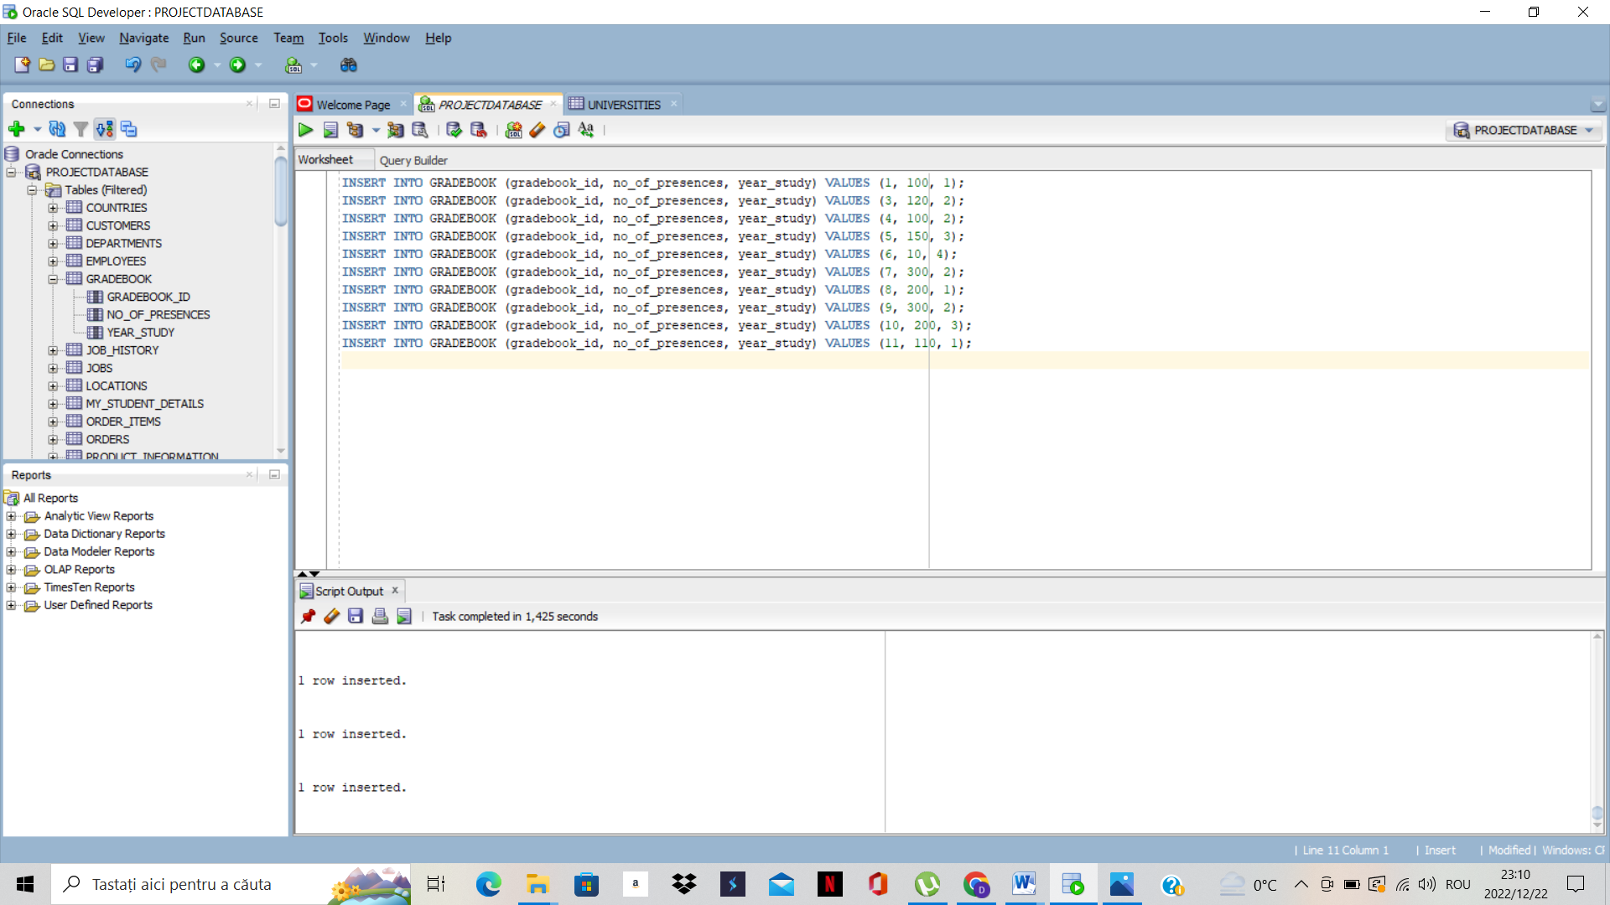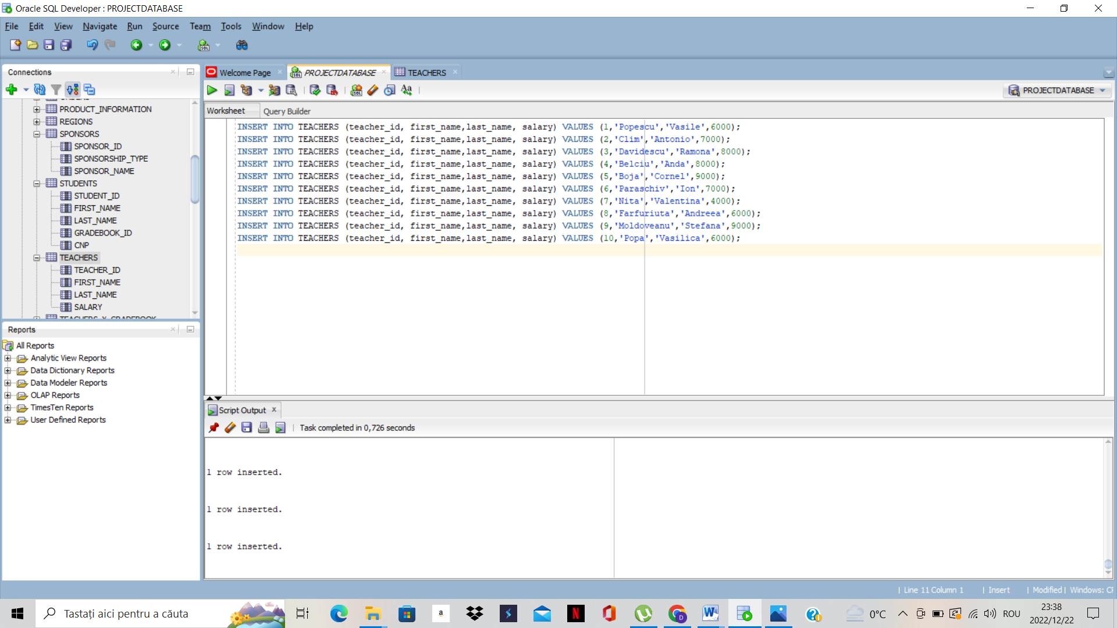

5) Informations about TEACHERS:

INSERT INTO TEACHERS (teacher_id, first_name,last_name, salary) VALUES (1,'Popescu','Vasile',6000);

INSERT INTO TEACHERS (teacher_id, first_name,last_name, salary) VALUES (2,'Clim','Antonio',7000);

INSERT INTO TEACHERS (teacher_id, first_name,last_name, salary) VALUES (3,'Davidescu','Ramona',8000);

INSERT INTO TEACHERS (teacher_id, first_name,last_name, salary) VALUES (4,'Belciu','Anda',8000);

INSERT INTO TEACHERS (teacher_id, first_name,last_name, salary) VALUES (5,'Boja','Cornel',9000);

INSERT INTO TEACHERS (teacher_id, first_name,last_name, salary) VALUES (6,'Paraschiv','Ion',7000);

INSERT INTO TEACHERS (teacher_id, first_name,last_name, salary) VALUES (7,'Nita','Valentina',4000);

INSERT INTO TEACHERS (teacher_id, first_name,last_name, salary) VALUES (8,'Farfuriuta','Andreea',6000);

INSERT INTO TEACHERS (teacher_id, first_name,last_name, salary) VALUES (9,'Moldoveanu','Stefana',9000);

INSERT INTO TEACHERS (teacher_id, first_name,last_name, salary) VALUES (10,'Popa','Vasilica',6000);

6) To continue, I will create the relations between the foreign keys and the primary keys between main tables.I will begin with teachers x universities:

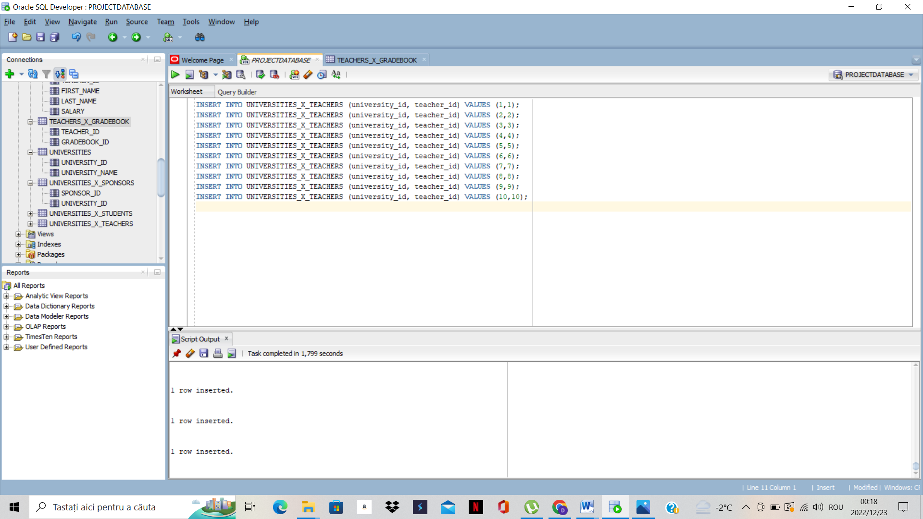

7)To continue, I will create the relations inside sponsors and universities table:

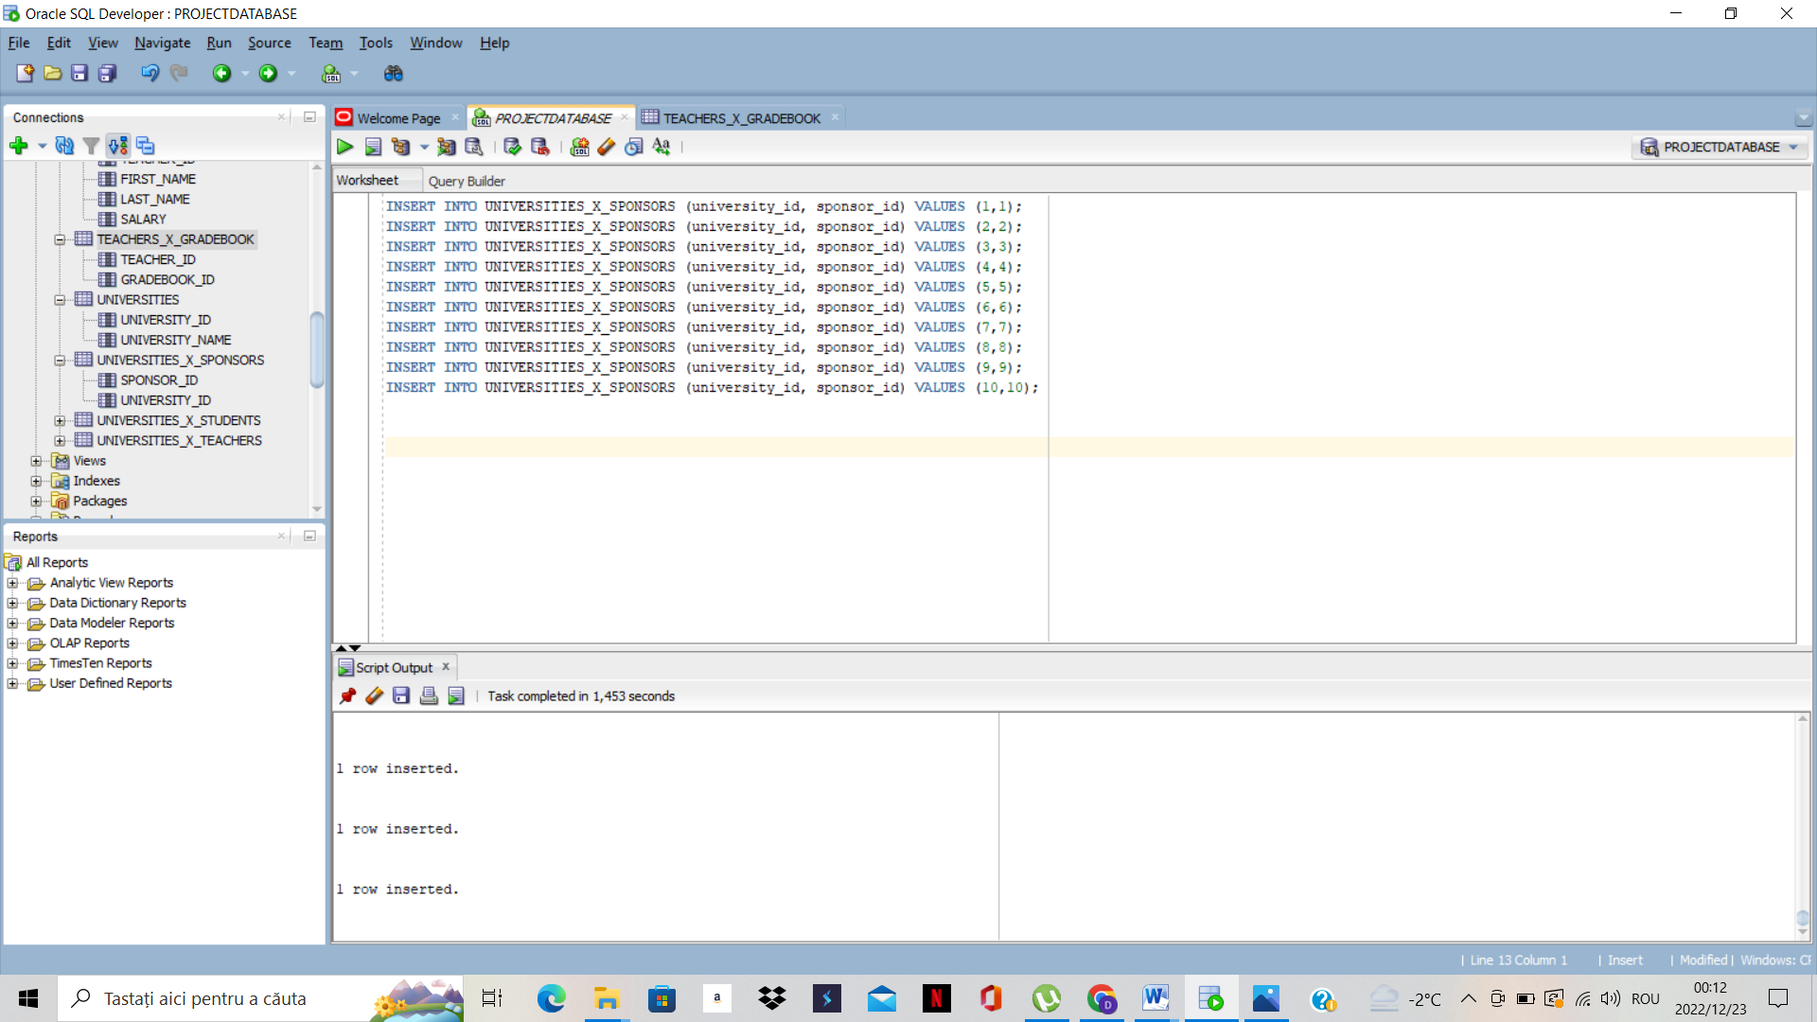

8)Then,we create the table who gives the relation between universities and students:

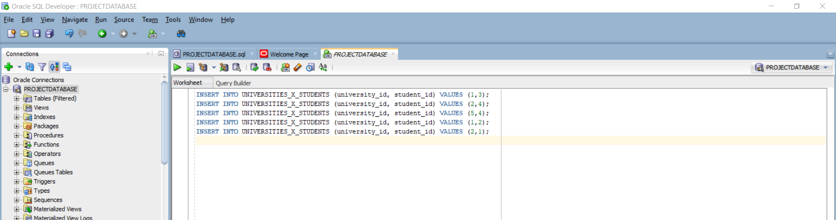

Finally, I have created the table who gives the relationship between teachers and gradebooks:

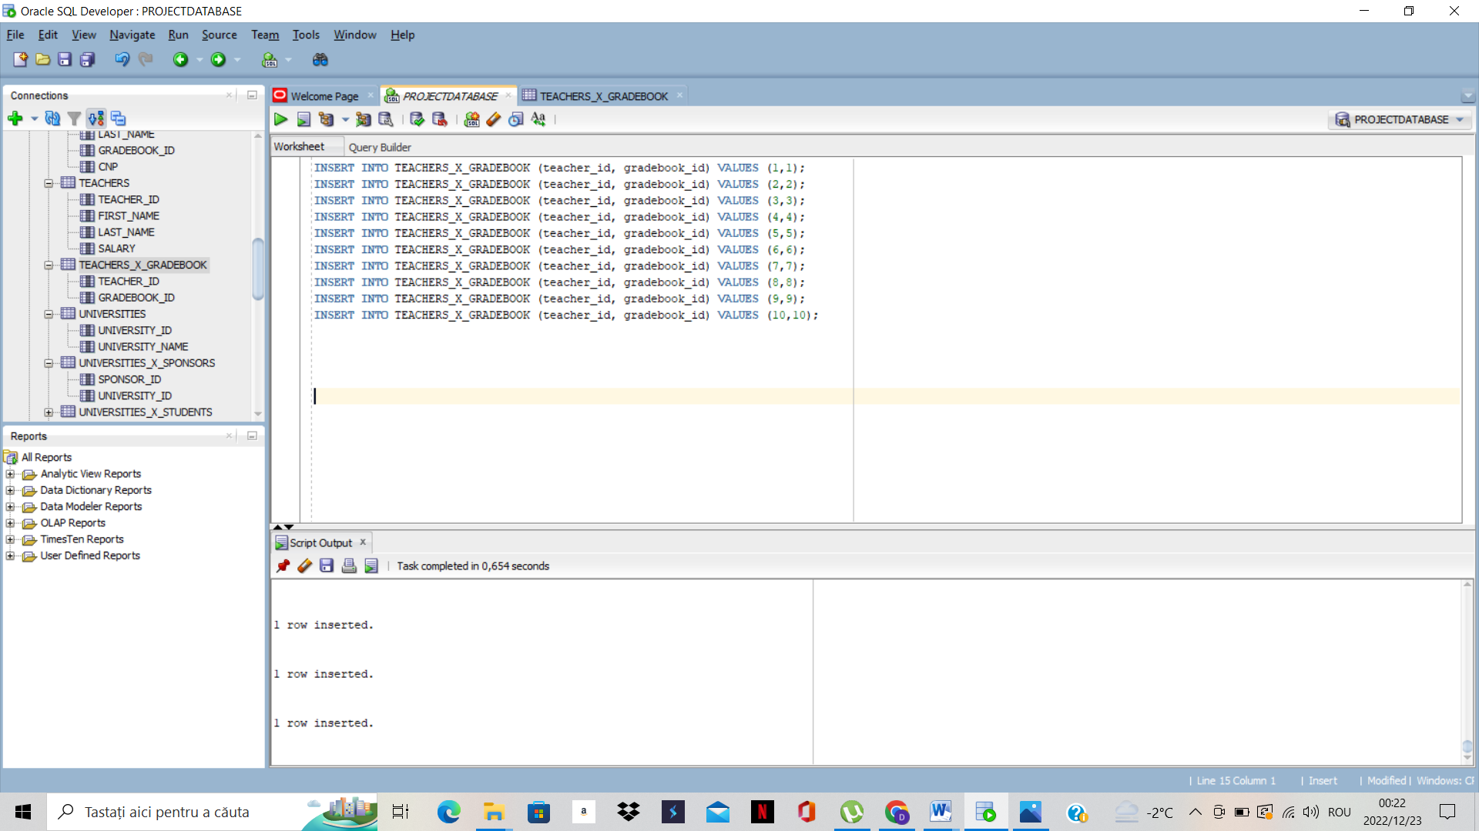

For the data to be more accurate, I am going to introduce some more INSERTS to create „many to one” relationships between the tables.

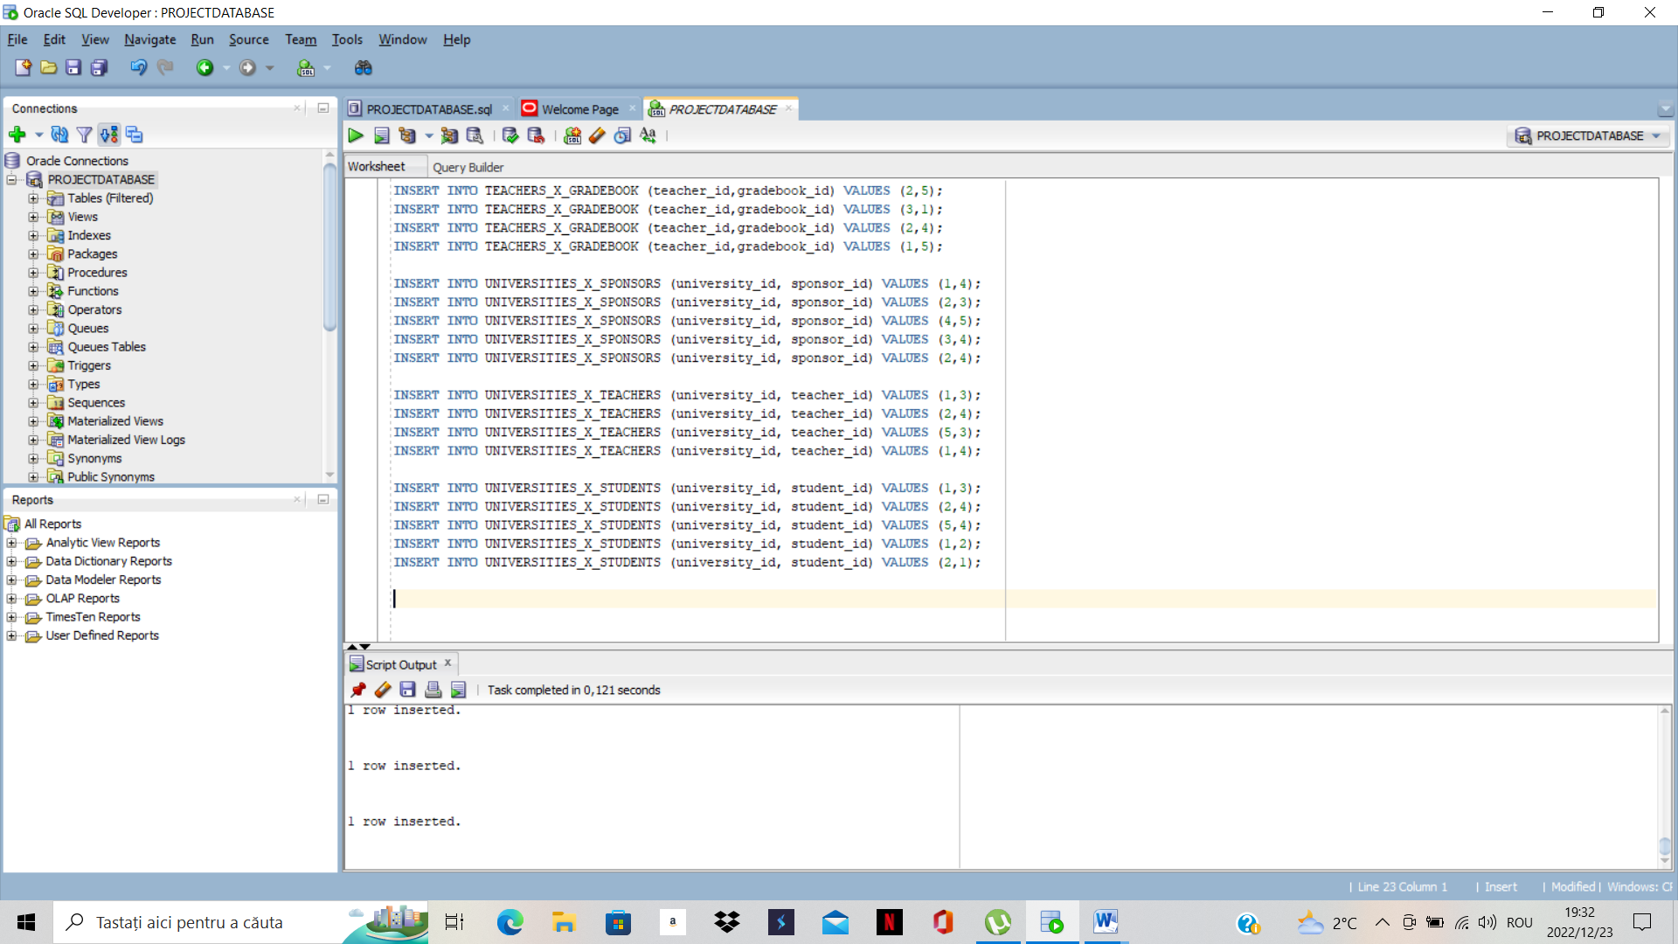

2)To continue, I will create some UPDATE statements:he

In those UPDATE statements, I changed the name of some teachers and some students because most of the time in real world it is very possible to mistake the names being a variety of them.

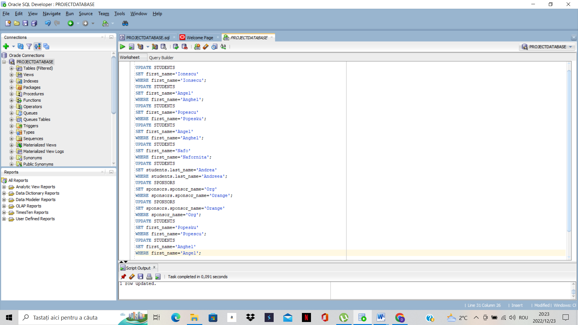

3) Then, we will create some DELETE statements:

With this option specially designed in SQL for deleting informations about different people, I deleted some ids from all the main tables

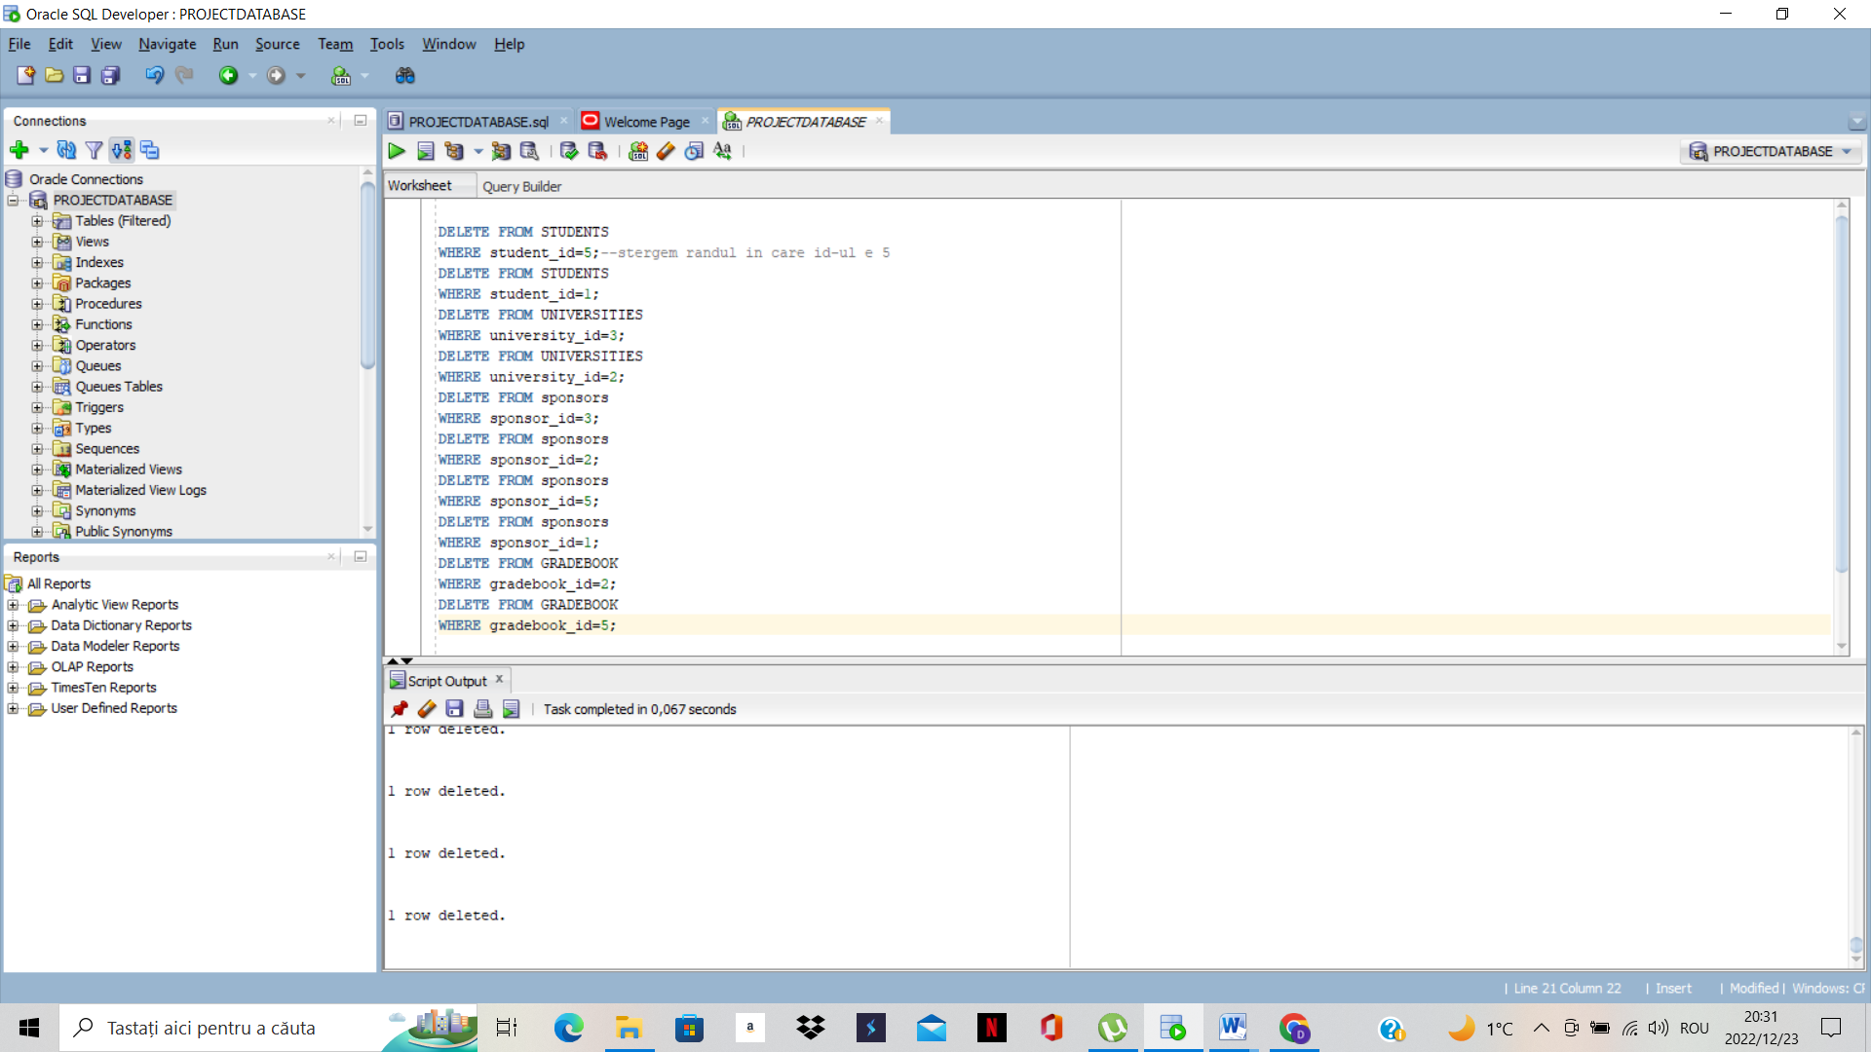

Finally, we should have created some MERGE statements but in my opinion, this statement is not right for this database, so I will omit this statement.

Because it’s mandatory, I will INSERT my name in „my_student_details” table:

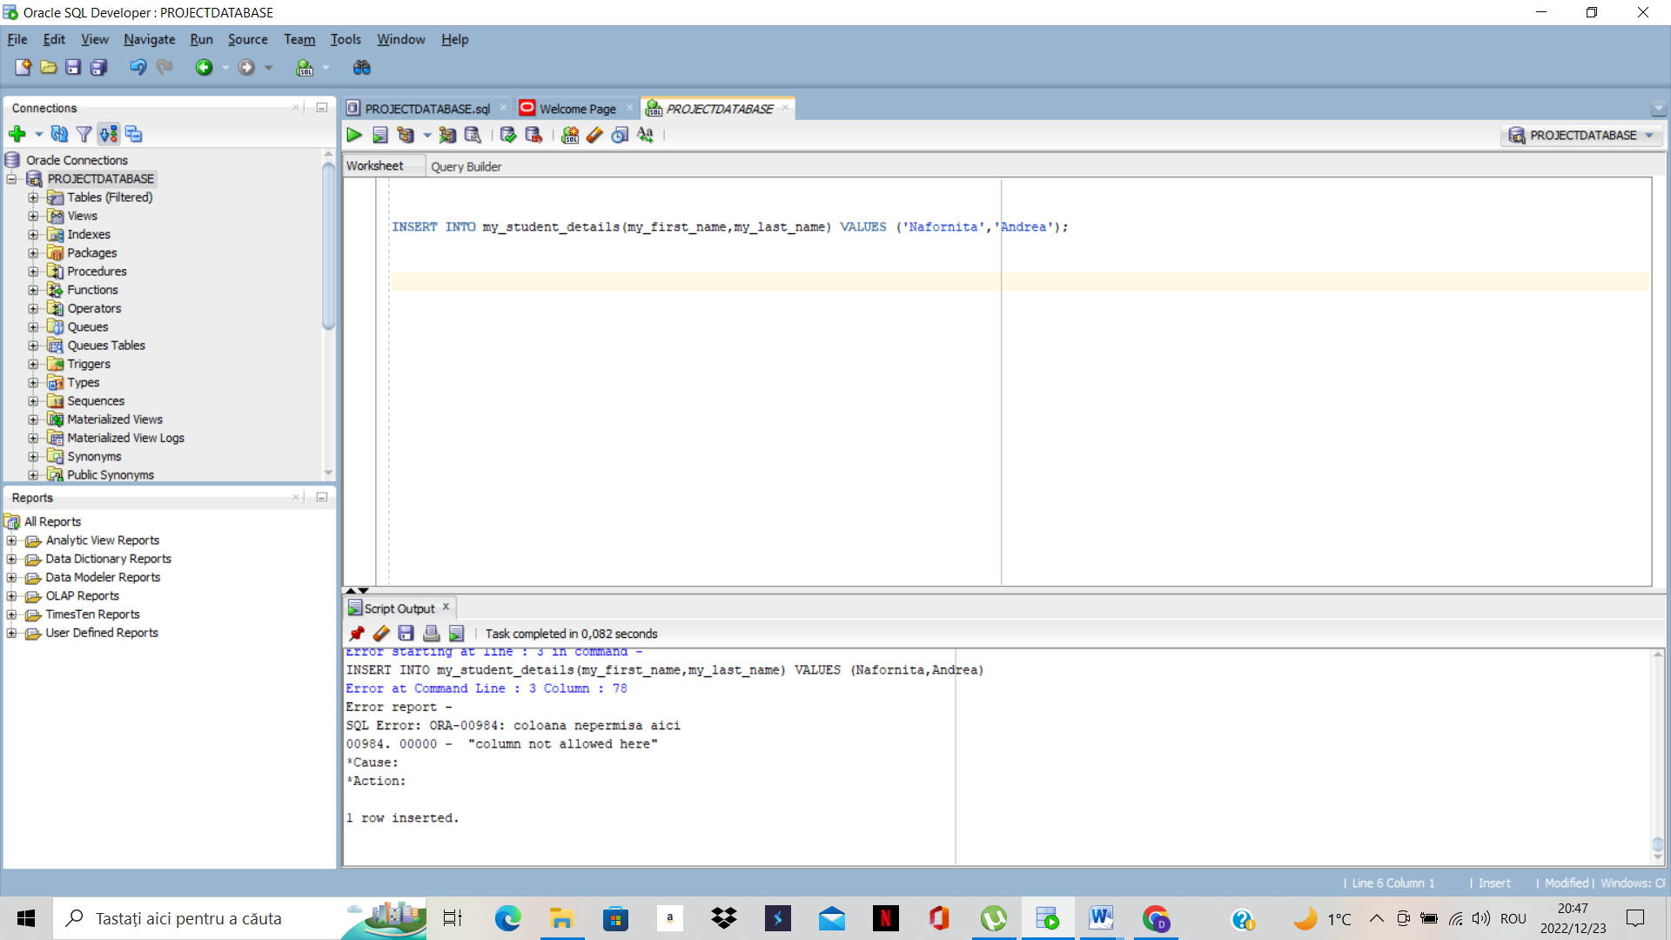

***4.Diverse and relevant SELECT statements for the project theme***

In the first statement, I have selected the first name from all students from the table student.

In the second statement, I have selected first name and last name from table students and I ordered by first name.

In the third statement, I have selected all the student’s first name and all the teacher’s last name on condition that student’s id is equal to teacher’s id.

In the fourth statement, I have selected all the student’s first name and all the teacher’s last name on condition that student’s id is not equal to teacher’s id

In the fifth statement, I have selected all the student’s first name and all the teacher’s last name on condition that student’s id is not equal to teacher’s id but in another way (<>)

In the statement number 6, I have selected all the student’s first name and last name from the table student and I ordered them in descending order

In statement number 7, I have selected from table teachers, all ids and first name (first name will be displayed with upper letters) on condition that ids are equal to 1.

In statement number 8, I have selected from table students all ids and last names on condition that last name contains letter „S”.

In statement number 9, I have selected from table students all ids and last names on condition that last name is equal to POPESCU.

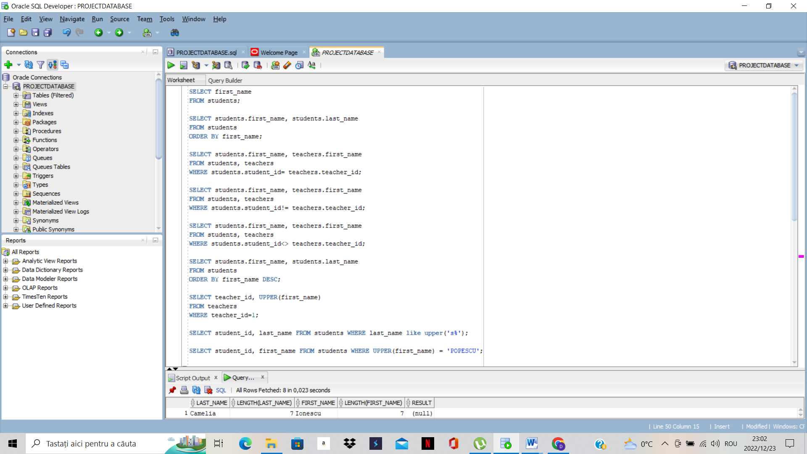

In the second screenshot who is situated below, I done some other statements that we can apply in any database:

In statement number 11,I have selected all ids and names from student table on condition that ids are in between 1 and 4, and I have also selected all ids and names from teacher table on condition as previous with student table.

In statement number 12, I have selected all names from table teachers, on condition that the salary is minimum from the row.

In statement number 13, I have selected all ids and names from table teachers on condition that id is null.

In statement number 14, I have selected all ids and names from table students on condition that i dis equal to 1,2 or 3

In statement number 15, I have selected last name, lenght of last name, first name, lenght of first name, and if lenght of first name is not equal to last name, will be set to null, if not, will be displayed, from table students.

**THANKS FOR WATCHING!  
☺**

